CN Lab-1
Abdullah
24k-0859
BCS-5H
Task A:
1) Find the IP address of the computer you are using and the IP address version.
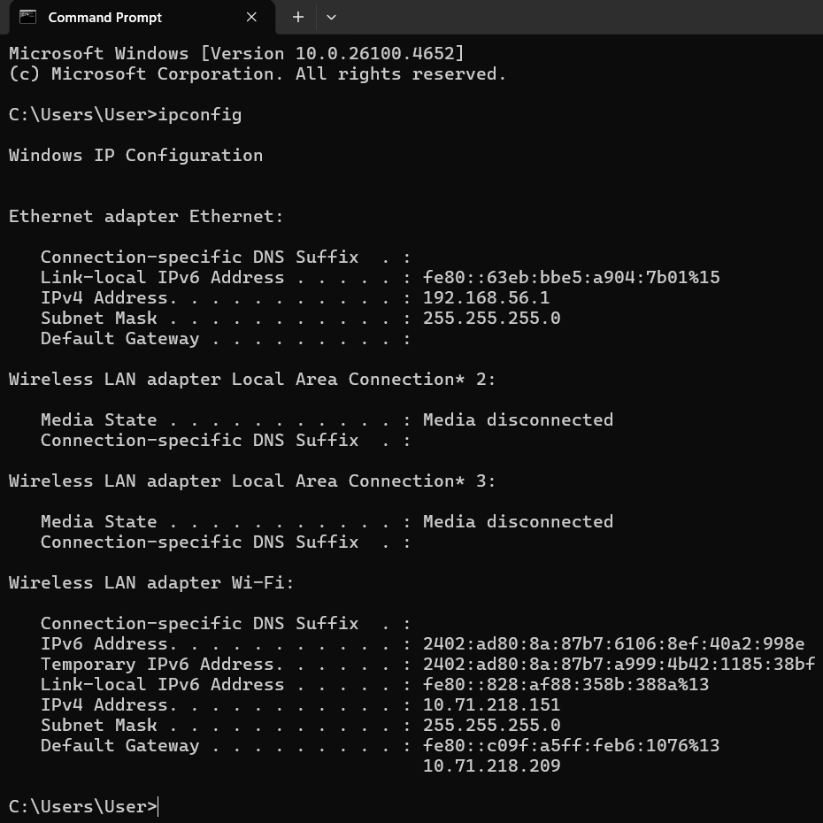
Command: ipconfig
IP Address: 192.168.56.1
IP Address version: IPv4
2) Find the subnet mask of the computer you currently use, MAC address, the gateway, and whether DHCP is turned on.
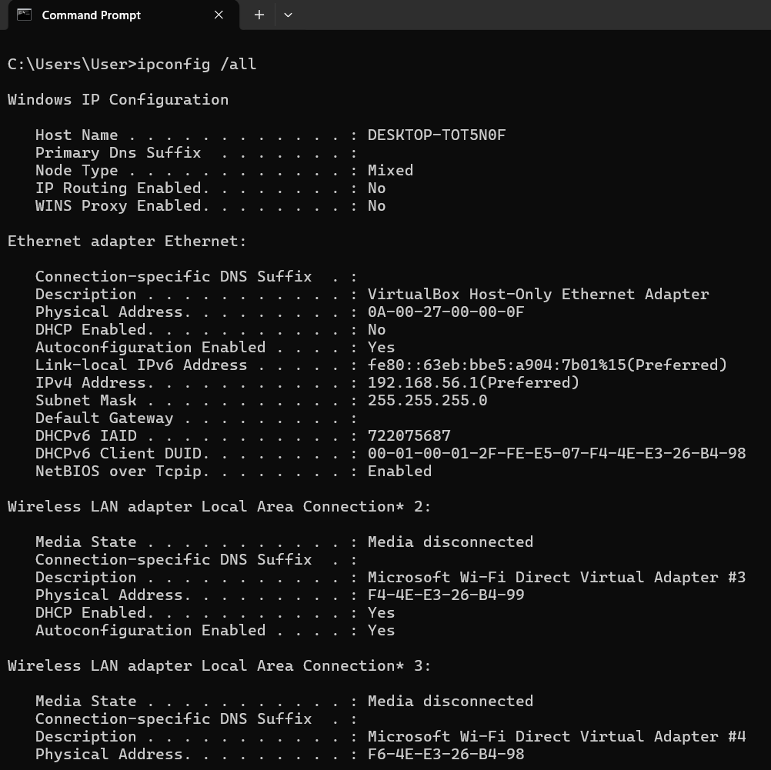
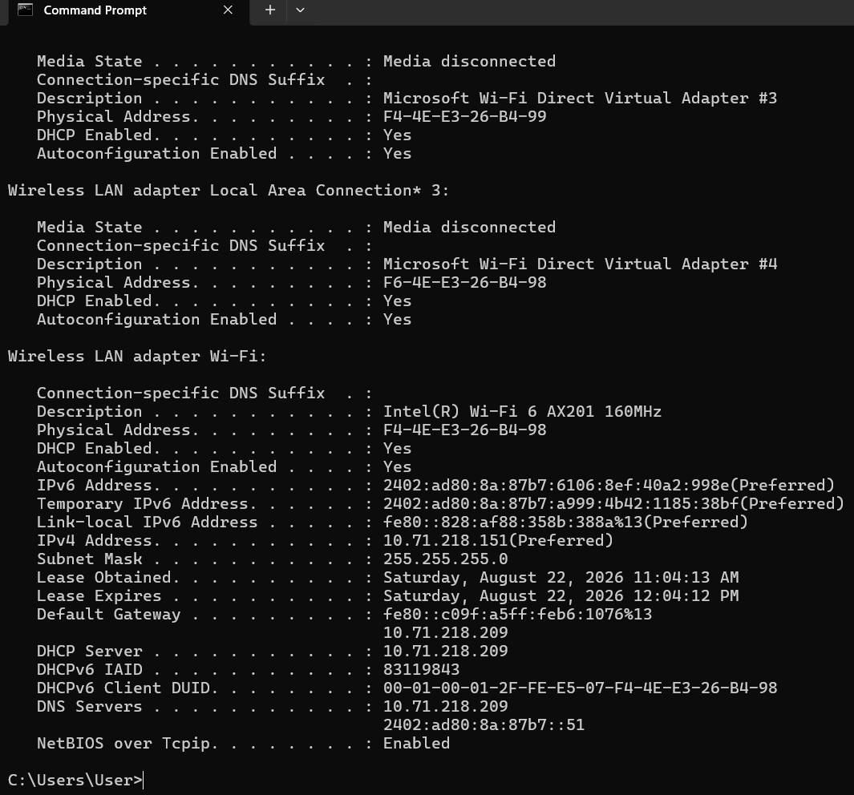
Command: ipconfig /all
Subnet Mask: 255.255.255.0
MAC address: 0A-00-27-00-00-0F
Gateway: fe80::c09f:a5ff:feb6:1076%13 10.71.218.209
DHCP status: Yes
3) Display the hostname of the computer and which protocol needs to be installed to access this command.
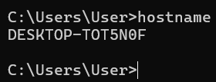
Command: hostname
Hostname: DESKTOP-TOT5N0F
Protocol Name: Needs to be installed.

4) By which command do we check basic IP connectivity between two computers, check the
connectivity with any other computer, and state the reason whether it's connected or not?
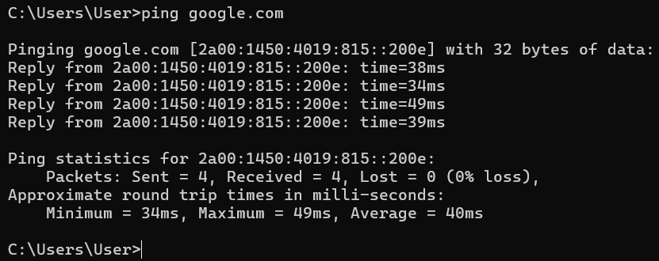
Command: ping google.com
Reason: Ping works by sending ICMP Echo Request packets to the target and waiting for Echo reply packets back. If replies are received, the two hosts have working end-to-end network connectivity, if requests time out or return "unreachable," it indicates a routing, firewall, or connectivity failure somewhere along the path.
5) Find out which ports on your host are connected to applications. Connect the browser to some external web page before running the appropriate command.
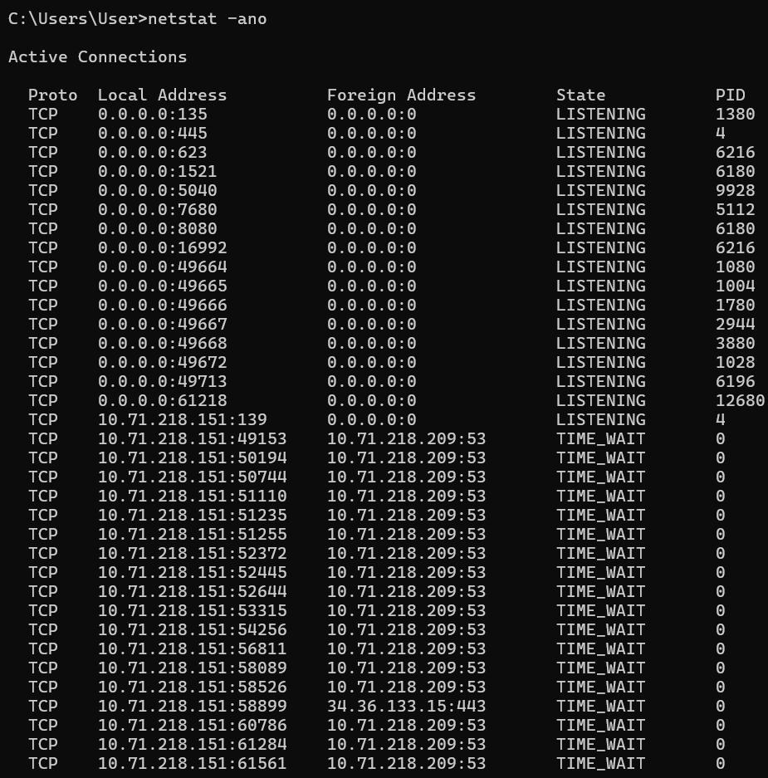
Command: netstat -ano
Reason: Netstat shows active TCP/UDP connections including local/remote port numbers and connection state, confirming which ports are in use by which application.
6) Find the path of routers to at least three websites (of your own choice). What is its IP address? How many hops are involved in the path?
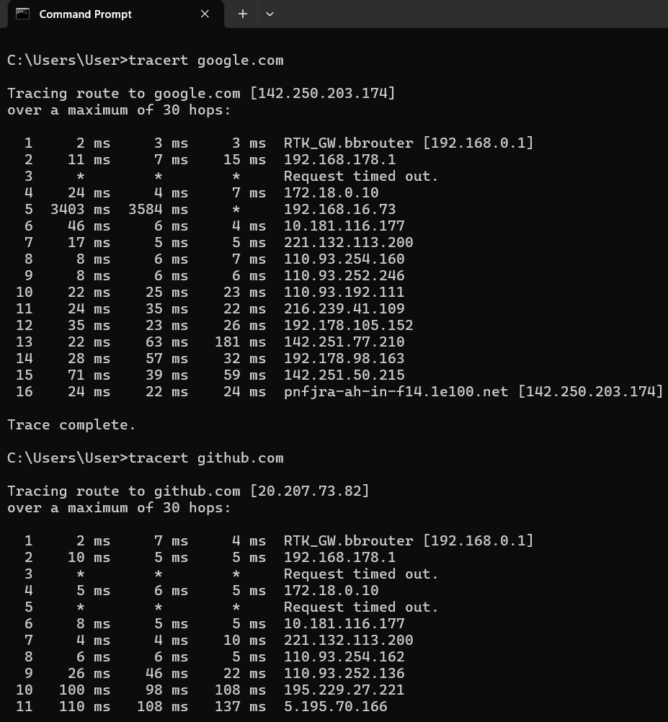
Command: tracert site.com
IP Address in ScreenShots
Total Hops = 52
7) A ping to 8.8.4.4 works but a ping to the machine’s name “Syrin machine” fails. What could be wrong? Write reason in concise form (1 to 2 sentences).
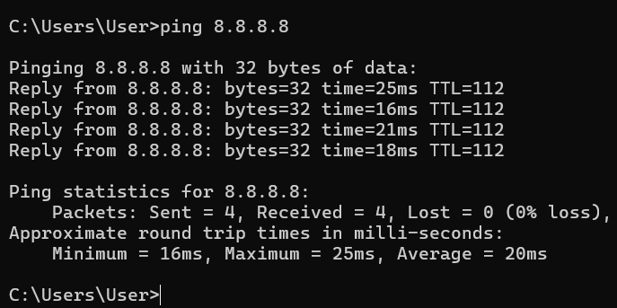
Reason: Ping to 8.8.8.8 returned successful replies, confirming the connection is active since ICMP Echo Request/Reply packets were exchanged successfully between the two hosts.
8) If the order of the wires on both ends of the RJ45 connector is the same, which type of cable is used?
Answer: Straight-through cable.
9) Can you connect a Router Ethernet port to the PC NIC using a straight-through cable?(Yes/No)
Answer: No
10) Can you connect a Switch to a PC or server using a crossover cable?(Yes or No)
Answer: No
11) Can you connect a Hub to a PC or server using a straight-through cable?(Yes or No)
Answer: Yes
12) Find all other hosts available on the network.
Command: arp -a
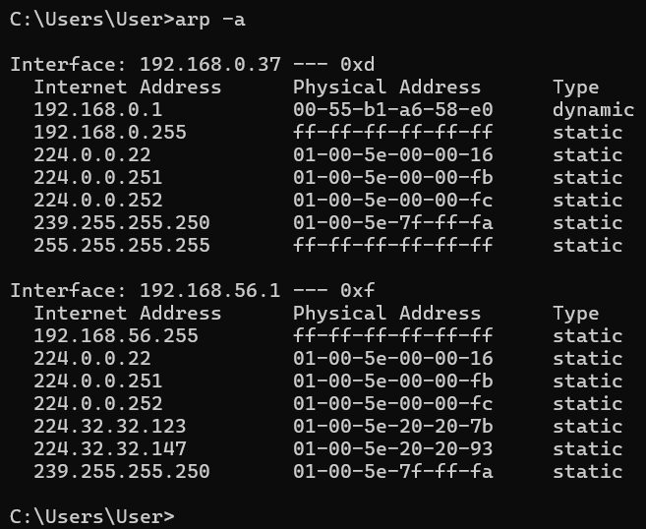

13) Check any port on TCP and show the results.
Command: netstat -an -p TCP
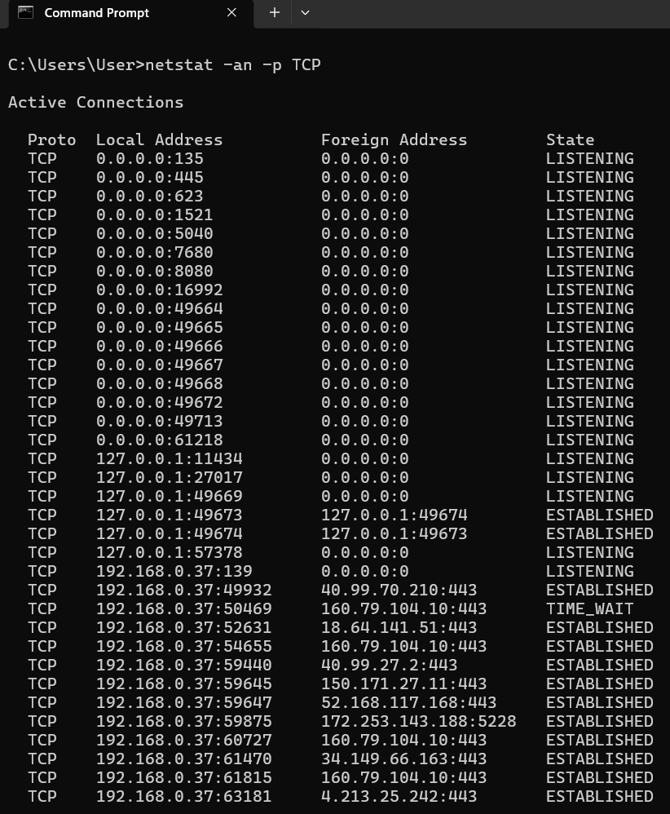
14) Display the number of datagrams sent and received.
Command: netstat -s
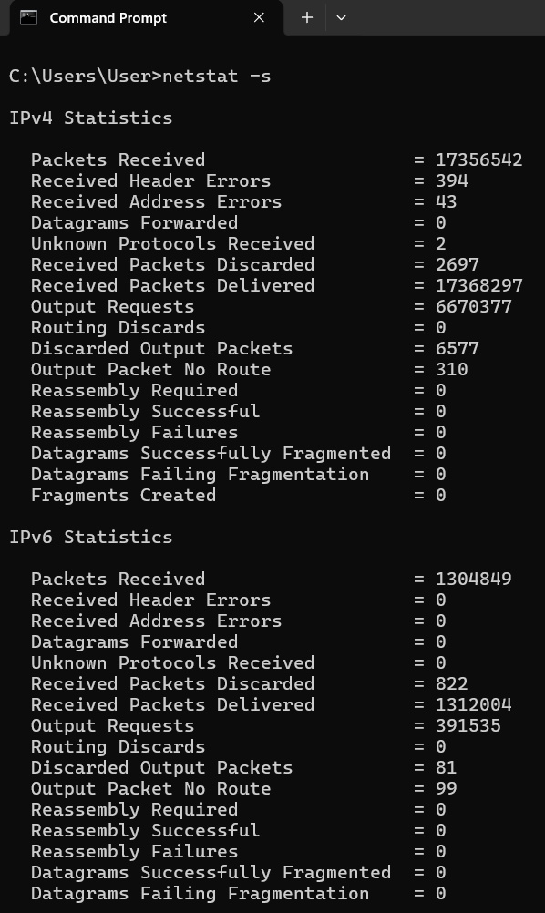
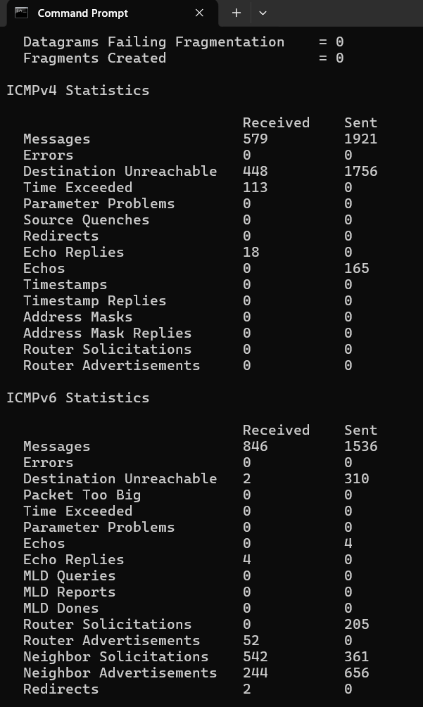
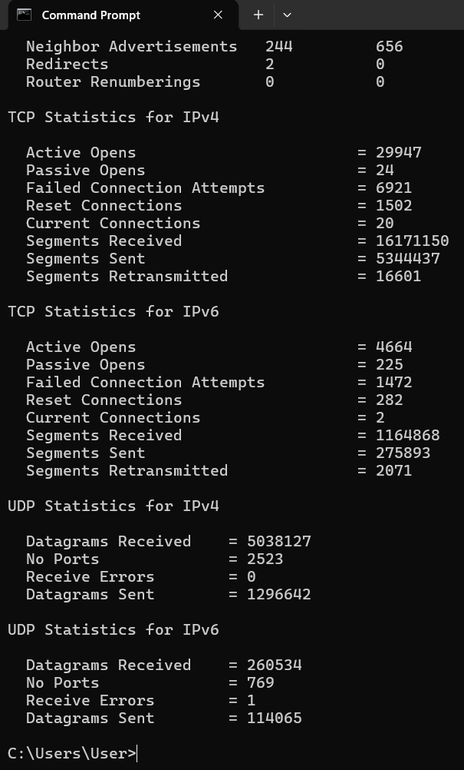
Task B:
Class Exercise: Address Class Identification:
Address Class
10.250.1.1 A
150.10.15.0 B
192.14.2.0 C
148.17.9.1 B
193.42.1.1 C
126.8.156.0 A
220.200.23.1 C
230.230.45.58 D
177.100.18.4 B
119.18.45.0 A
249.240.80.78 E
199.155.77.56 C
117.89.56.45 A
215.45.45.0 C
199.200.15.0 C
95.0.21.90 A
33.0.0.0 A
158.98.80.0 B
219.21.56.0 C

Class Exercise: Host & Network Identification:
Address Network Portion
177.100.18.4 177.100
119.18.45.0 119
209.240.80.78 209.240.80
199.155.77.56 199.155.77
117.89.56.45 117
215.45.45.0 215.45.45
192.200.15.0 192.200.15
95.0.21.90 95
33.0.0.0 33
158.98.80.0 158.98
217.21.56.0 217.21.56
10.250.1.1 10
150.10.15.0 150.10
192.14.2.0 192.14.2
148.17.9.1 148.17
193.42.1.1 193.42.1
126.8.156.0 126
220.200.23.1 220.200.23

Host Identification:
Address Host Portion
10.15.123.50 15.123.50
171.2.199.31 199.31
198.125.87.177 177
223.250.200.222 222
17.45.222.45 45.222.45
126.201.54.231 201.54.231
191.41.35.112 35.112
155.25.169.227 169.227
192.15.155.2 2
123.102.45.254 102.45.254
148.17.9.155 9.155
100.25.1.1 25.1.1
195.0.21.98 98
25.250.135.46 250.135.46
171.102.77.77 77.77
55.250.5.5 250.5.5
218.155.230.14 14
10.250.1.1 250.1.1

Class Exercise: Network Addresses:
Network Address
188.10.0.0
10.10.48.0
192.149.24.0
150.203.0.0
10.0.0.0
186.13.23.0
223.69.0.0
200.120.135.0
Class Exercise: Host Addresses:
Host Address
0.0.18.2
0.0.0.80
0.0.0.11
0.0.230.19
0.10.10.10
0.0.0.11
0.0.23.20
0.0.0.215

Class Exercise: Default Subnet Masks:
IP Class Default Subnet Mask
103.236.162.56 A 255.0.0.0
162.252.172.41 B 255.255.0.0
180.181.68.221 B 255.255.0.0
203.134.40.41 C 255.255.255.0
211.26.68.46 C 255.255.255.0
17.255.253.65 A 255.0.0.0
1.128.96.254 A 255.0.0.0
108.161.213.25 A 255.0.0.0
12.198.43.9 A 255.0.0.0
211.27.133.39 C 255.255.255.0

